|  |
| --- |
|  |
| User Guide  Dynamics CRM Online |
| **Corporate Office Solutions** |
|  |

|  |
| --- |
|  |



Table of Contents

Table of Contents 1

CRM General Concepts 3

CRM User Interface 3

Navigation 3

Record Lists and Forms 5

Other Outlook Interface Features 10

Activities 14

Outlook Integration 16

Advanced Find 19

Account Management 23

Accounts 23

Hierarchical Accounts 23

Addresses 24

Contacts 26

Outlook Integration 26

Buildings and Tenants 27

Competitors 29

Connections 31

Create a connection 32

Sales Process Management 33

Opportunities 33

Creating Opportunities 33

Closing Opportunities 36

Reopen an Opportunity 37

Orders 38

Order Information 39

Close Orders 42

Reopen Order 42

Document Management 44

Reporting and Analytics 47

Reports 47

Report Filtering 48

Exporting Reports 50

Charts 51

Dashboards 54

Drill down in a chart 54

Enlarge a chart 55

View the records that are used to generate the chart. 55

Apply filters on the list 55

Refresh all components in the dashboard 55

# CRM General Concepts

## CRM User Interface

1. At a very basic level, Dynamics CRM 2011 manages relationships between pieces of information. In this chapter, you will learn to navigate around CRM and learn where to find what is important to you, and your customers.
2. Dynamics CRM has a concept of modules and the CRM user interface follows the approach of allowing direct navigation to each of the modules available to a user.

### Navigation

To navigate around the different CRM modules from Microsoft Outlook, locate your organization in the Outlook folder list on the left menu. When you expand the organization you will see the list of CRM modules. This is the Navigation menu:

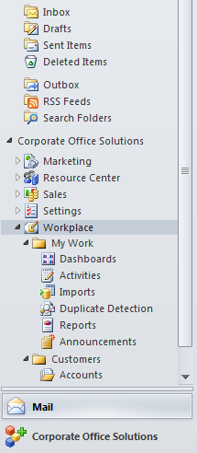

**NOTE: Depending on your CRM security role, not all the options described in this manual may be available to you. Each CRM user only has access to the functionality he or she will use, as defined in the user’s CRM security role.**

The available CRM modules are:

* 1. **Workplace**. In this module, you find the most commonly used items, regardless of user role: user activities list, dashboards, accounts and contacts.
  2. **Sales**. The Sales Module is where to find Leads, Opportunities, Orders, Products, Buildings and Tenants information.
  3. **Marketing**. Here you will find all the items a marketing professional might use. Leads, Accounts, Marketing Lists, Products, Marketing Campaigns.
  4. **Settings**. The Settings Module is where all system customizations can take place as well as some other functions such as process management, system Imports/Exports. Here is where you also manage user account and security roles. The Setting Area takes into account permissions and security roles and only shows a user what their role entitles them to access.
  5. **Resource Center**. The Resource Module is the place to get custom help on the various modules. Each of the system modules has an area here with popular content, recent content, training links, support links, etc.

As you navigate, notice the Ribbon menu on the top of the screen. The Ribbon is context based, meaning it will show you different options depending on the currently selected item.



### Record Lists and Forms

#### Lists

When selecting an item from the Navigation menu, Outlook displays the information in a grid containing columns from the selected entity. In the image below you can see an example of the Accounts list.

* 1. While viewing a CRM grid within Outlook, you can see a preview of the currently selected record directly below the grid.

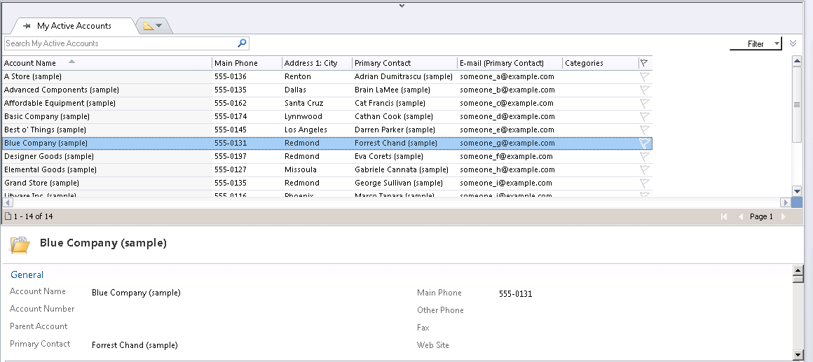

* 1. Preview record contents

You can search for information in each list by using the search text box located above the grid. Note that the system only searches for the primary attribute of each entity, for example the Account name.

Lists can also be filtered further by applying custom conditions to columns using the button to the right of the Search box. The filtering mechanism is very similar to the one used in Microsoft Excel.

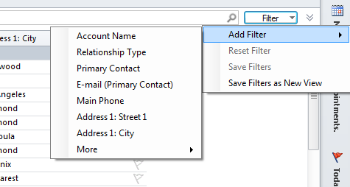

* 1. *Applying custom filters*

##### Tabbed views

* 1. The CRM user can select a different view for each grid from the list of defined views for the current entity. The different views show information pre-filtered by different criteria along with the relevant data columns. For example, the Accounts: No Orders in the last 6 Months view shows all the Account records for which an order was not created in the past 6 months.
  2. The user can add multiple tabs for their common views for faster navigation and data loading for commonly viewed items. This is achieved by selecting the desired view from the tabs at the top of the grid.

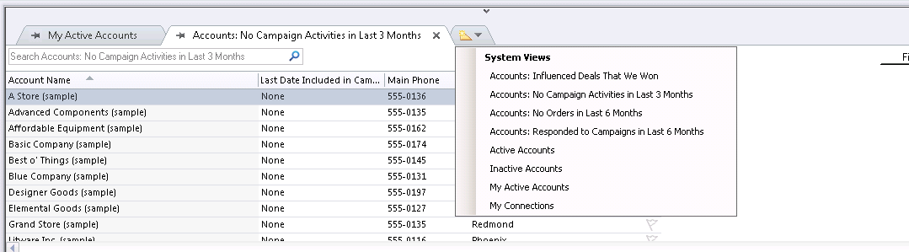

* 1. Add a new tabbed view

#### Forms

When you open a record from one of the lists (by double-clicking it), the record form is displayed. The Form contains the detailed information for that record, along with all the related information from the system. Using the record forms you can view, edit or create records.

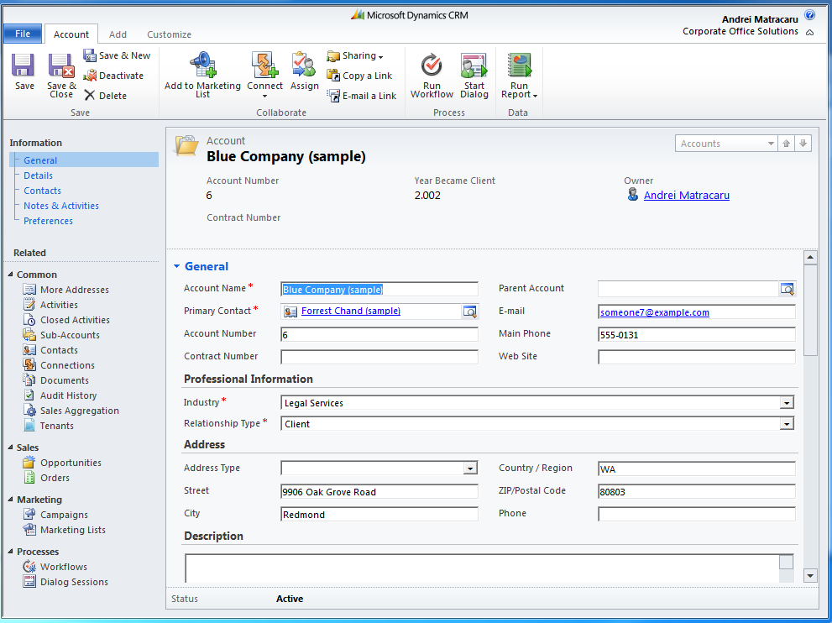

*Account Form*

Every CRM record form contains the following sections:

1. Form Header: contains important information for quick viewing. For example, the Account form header contains information about the Account Number, the year the account became a client and also the account owner.
2. Form Body: contains editable fields for all the record’s details
3. Left Navigation Pane: links to other entities in the system that contain information related to the current record (for example, opportunities for the Account record that you are viewing).
4. Ribbon Menu (located at the top): using the menu you can perform different operations on the current record (save, delete, deactivate, connect with other records, assign or share information with another user, and so on).

To create a new record of any type, you can open the record’s list from the Navigation menu and click the **New** button on the ribbon. A form will open in create mode to allow you to record information. To save the record, click the **Save** button on the form’s ribbon menu.

##### Form Field Types

The following field types are available on forms for you to record the necessary information:

1. Free text fields: you can enter the information in any format you like, although for some special attributes the system accepts only a pre-defined format for the data (for example email fields, that must be formatted as [*name@domain.com*](mailto:name@domain.com)).
2. Pick lists: you must select one of the predefined values from the list



1. Date / time fields: for date / time information, you can click the caledar icon on the right of the field in order to select the desired date from a caledar



1. Money fields: these fields only accept numeric values; they also show the currency symbol



1. Lookup fields: these fields allow you to search for records in the system and select one or more records, depending on the lookup type.



Lookups can either search for a single record type (for example Accounts) or more record types (Accounts, Contacts, Bulildings, and so on).

To search for a record using a lookup, you can either type the name of the record you are searching for in the lookup textbox (the system will present some options for you to select for it it finds more than one match), or you can use the lookup search dialog. To open the search dialog, click the button on the right of the lookup text field.

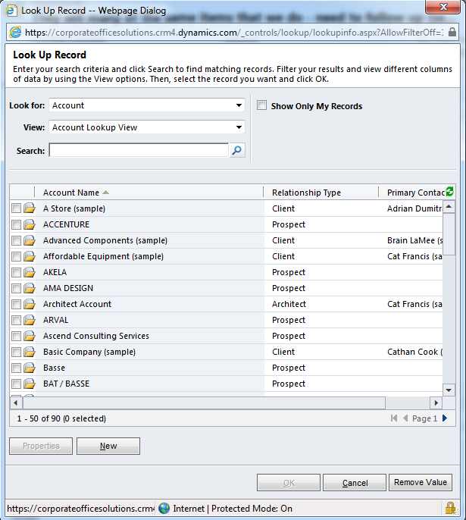

*Lookup search dialog*

Using the seach dialog, you can select the type of record to look for and the View displayed in the lookup grid. If the records you are looking for does not exist in the system, you can use the New button (below the grid) to create a new record in the system.

**NOTE**: the fields marked with the red asterisk symbol are required fields; that means that you cannot save the record until all the required fields are completed.

### Other Outlook Interface Features

#### Outlook choices from CRM view

* 1. While viewing a CRM grid, you can right click on a record and have common Outlook choices available, such as follow-up and categories.

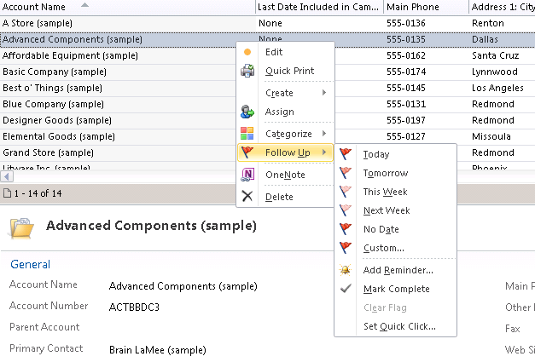

* 1. Add category or follow-up flags

#### Conditional Formatting

* 1. CRM users in the Outlook client can add conditional formatting. One example of conditional formatting would be to show all accounts that are located in Redmond in a different font size and color than the others.

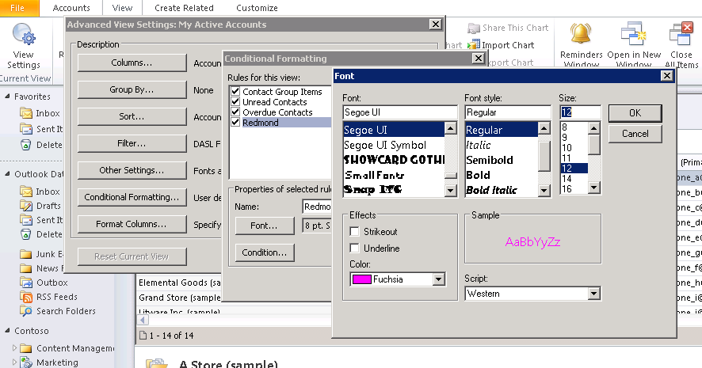

* 1. Conditional formatting dialog

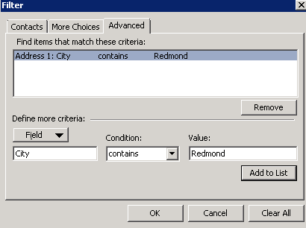

* 1. Add your clause

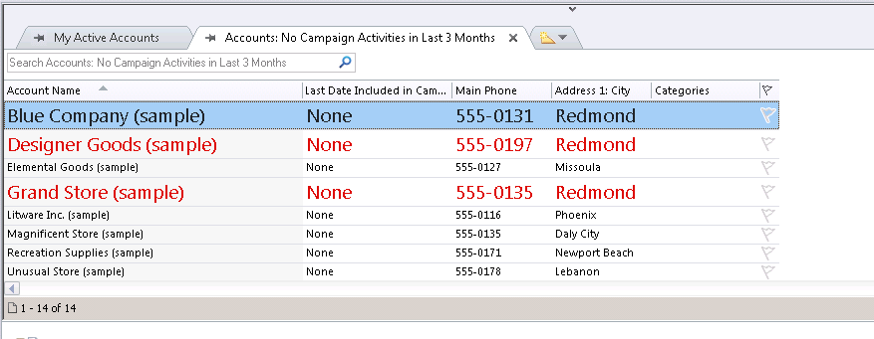

* 1. Updated grid with conditional formatting

## Activities

Dynamics CRM allows you to define and track different activities and interactions with your customers. The main types of activities that can be created in the system are:

* Task
* Fax
* Letter
* Phone call
* E-mail
* Appointment

There are additional activity types that are created automatically by other processes:

* Opportunity Closures
* Order Closures
* Campaign responses

To view the list of activities defined in the system, in the **Navigation** menu, click **Workplace**, and then under **My** **Work** click **Activities**.

To work with activities associated with a record, open the record and then click **Activities** from the left navigation pane of the form.

#### Create Activities

To create activities in CRM you can follow these steps:

1. To add new activities from the **Activities** list, on the **Activities** tab in the **New** group, click the type of activity you want to add.

- OR -

1. To add a new activity from a record, click **Add New Activity**. Select an activity type, and then click **OK**.
2. Enter the information that you want. At a minimum, entering information in the following boxes is useful when you or others in your organization refer to the activity at a later date:
   * **Subject**

Enter a meaningful description that can help you easily identify the activity in the Activities list view. The subject field is required because, by default, most of the Activities views are sorted by it.

* + **Regarding**

This field is used to link the activity to another record so that you can view the activity from the record. If you create a new activity from a record, this is automatically filled out.

* + **Owner**

This box represents the user who owns the activity. By default, it is set to the user who creates the activity.

* + **Due**

Enter the date and time that the activity is expected to take place or be completed. You can quickly sort on the **Due** field when you view activities.

Some activities also have the following optional fields:

* + **Sender**

You can use this field to record the user in your organization who initiated an outgoing communication. Alternatively, if this is an incoming communication from a customer, you can select the lead, account, or contact who initiates the communication. The sender must be a valid Microsoft Dynamics CRM Online account, contact, or lead, but can also be a Microsoft Dynamics CRM Online user. By default, this box contains the name of the user who creates the activity.

* + **Recipient**

This is the person, typically an account, contact, lead, or Microsoft Dynamics CRM Online user, that receives the communication.

* + **Category**, **Sub-Category**

You can use these text fields to categorize tasks so that you can sort or view your tasks by category and/or sub-category.

1. Click **Save** or **Save and Close**.

**NOTE**: By relating the activity to a specific record, such as an email to a contact record, you create a history of the communications with that customer that other people in your organization can view.

**NOTE**: Some activities can be converted to other record types. For example, an e-mail received from a customer can be converted to an opportunity.

#### Close Activities

* Tasks
* Faxes
* Phone Calls
* Letters
* Appointments
* Service Activities
* Campaign Activities

Unless you have created an activity record by mistake, it is better to close or convert an activity than to delete it. You can view closed or converted activities at a later date for reference, or run reports to determine the success rate of your activities.

To close an activity:

1. Open the activity that you want.
2. On the **Actions** menu, click **Close activity type**. For example, if you are in a task record, click **Close Task**.



1. In the confirmation dialog box, select the status that you want from the **Status** list, such as **Completed** or **Canceled**, and then click **OK**.

NOTE

* When you close an activity, the activity becomes read-only and cannot be edited or reopened.
* To view closed activities, do one of the following:
  + In the Activities list, select the **Closed Activities** view.
  + From an Account, Contact, Lead, or Opportunity record, under **Common**, click **Closed Activities**. In the **Filter on** and **Include** lists, select the view options that you want.
* It is not possible to close multiple activities at once.
* The only way to close an e-mail activity is to send it

### Outlook Integration

Dynamics CRM Online seamlessly integrates with Microsoft Outlook. Beyond the user interface integration, Outlook emails, tasks, appointments and contacts can be automatically synchronized with the CRM system and vice versa. The synchronization process automatically creates CRM activity records for the Outlook emails, tasks and appointments marked to be tracked in CRM. Also, Outlook appointments and tasks are created for each CRM Appointment and Task activity types created by you in the system.

#### Synchronizing and Tracking Microsoft Dynamics CRM Online Data with Outlook

You can track e-mail messages, contacts, tasks, meetings and appointments in Outlook to create a corresponding activity or contact record in Microsoft Dynamics CRM Online. You can link the item to a Microsoft Dynamics CRM Online record, also. Updates to the information can be done in both programs and can be accessed in both because the data synchronizes between the programs.

Microsoft Dynamics CRM Online for Outlook allows you to quickly choose the Outlook items that you want to track or stop tracking. Select one or more items to track. However, only choose a single item when wanting to stop tracking an item.

To track an Outlook item in CRM, simply select the item and click the Track button in the Ribbon menu.

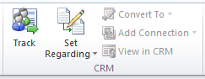

The process of linking an Outlook item to a Microsoft Dynamics CRM Online record only requires you to select one or more records, click the **Set Regarding** or **Set Parent** button, and then select an account or contact. Clicking **Set Regarding** or **Set Parent** automatically tracks the record, also.

You can link a record at any time, and this also tracks all replies to linked e-mail messages. Tracked e-mail messages, contacts, tasks, and appointments are updated to Microsoft Dynamics CRM Online immediately while you are online.

By default, tracked items display a Microsoft Dynamics CRM symbol rather than the standard Outlook symbols for e-mail messages, contacts, and tasks.



When you track Outlook items, you can also do the following:

* Select the regarding record for one or several items.
* Set the parent account or contact record for contacts.
* Add or edit connections.
* Convert e-mail messages, appointments, meetings, and tasks into Microsoft Dynamics CRM Online opportunity, lead, and case records.
* Open the record in Microsoft Dynamics CRM Online and open the parent and regarding record in Microsoft Dynamics CRM Online.
* Create new contact or lead records with the automatically create contact or lead records option selected.
* Insert and attach Microsoft Dynamics CRM Online e-mail templates to e-mail messages.
* Track tasks as Microsoft Dynamics CRM Online tasks, phone calls, letters, or faxes.

##### Synchronize with Microsoft Outlook manually

The Dynamics CRM Online synchronizes data with Microsoft Outlook automatically every 15 minutes. However, the synchronization process can also be run on demand using the following procedure:

1. If you have Outlook 2007 installed, on the **CRM** menu, click **Synchronize with CRM**.

- OR -

If you have Outlook 2010 installed, click **File**. Click the **CRM** tab, and then click **Synchronize with CRM**.

1. In the **Synchronizing Microsoft Dynamics CRM Data** dialog box, click **Common** to view the progress of the synchronization. You can view information on the following tabs:
   * **Tasks**. This tab displays information about the number of records and activities that are being synchronized.
   * **Errors**. This tab displays an explanation of any errors that occur during the synchronization process, so that you can correct them.

NOTE

If you receive the error message "CRM server Not Found", verify that you have Internet connectivity and that the Microsoft Dynamics CRM Online server is running. Then try synchronizing again.

##### Microsoft Dynamics CRM Pane in Outlook Items

When Microsoft Dynamics CRM Online for Outlook is installed, e-mail messages, contacts, tasks, and appointments include a Microsoft Dynamics CRM pane that displays information and links about the item and related records.

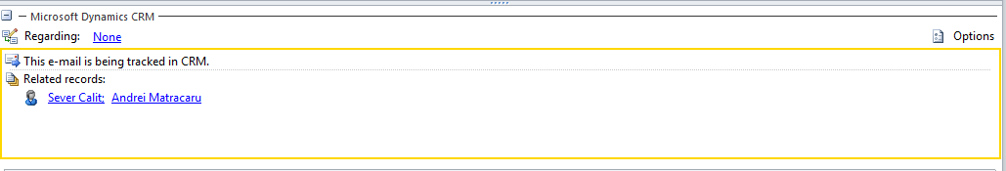

The Microsoft Dynamics CRM pane displays the following information:

* Whether the item is tracked.
* The name of the parent (for contacts) or regarding record.
* Related records, along with a symbol that identifies the record type in Microsoft Dynamics CRM Online.
* Whether the e-mail addresses, names, or distribution lists in the e-mail message are also Microsoft Dynamics CRM Online records.

**NOTE**

The Microsoft Dynamics CRM pane displays the name of the distribution list if you track an e-mail message without expanding the distribution list. If you expand a distribution list before you track and save an e-mail message, the individual e-mail addresses that comprise the distribution list are tracked, instead.

## Advanced Find

Advanced Find is a CRM tool that enables you to search for information in the system by custom defined criteria. Using Advanced Find you can also save the search as a personal view that can be accessed anytime from the Views list of the related entity.

To use Advanced Find:

1. To create a new search, in the CRM tab on the Ribbon click **Advanced Find**.

Tip

Advanced Find starts with criteria based on where you are in Microsoft Dynamics CRM Online. If you click **Advanced Find** from a view, Microsoft Dynamics CRM Online loads the criteria for that view.

- OR -

To edit a saved search, in the CRM tab on the Ribbon, click **Advanced Find**. Then, click the **Saved Views** tab, and double-click the saved view.

1. Specify the search criteria.
   * In the Look for list, select the type of record you want to search for, such as Accounts, Opportunities, or Users.
   * Click Select to select criteria for the search, including the field to search on (for example, Account Name or City), the [query relational operator](javascript:toggleInline('25007')) (Part of an expression (for example "is equal to" or "contains") that defines how a specified attribute should be compared with a value.), and the values to locate (for example, "Seattle" or "E-mail").

You can select fields from the current record type, or from [related records](javascript:toggleInline('25008')) (Records that are referenced in the current record. For example, an account might have many related contact records.).

* + - For some values, you can click the Lookup button to open the Select Values dialog box and select the value you want.



* + At the bottom of the **Select** list, the **Related** section shows [related record types](javascript:toggleInline('25009')) (Record types that are associated with another record type. For example, most record types have a related Notes record type.). When you select a related record type, a new **Select** link appears to select fields from this related record type.
  + Clear all search criteria to start over.
    - Click **Clear** to remove all criteria.
    - In the confirmation message, click **OK**.
  + Delete a row of search criteria.
    - Click the **Options menu** button next to a search criteria row, and then click **Delete**.



* + - In the confirmation message, click **OK**.
  + Group criteria.
    - Click the **Options menu** button next to a search criteria row, and then click **Select Row**.



To group search criteria, you must select two or more rows for the same record type.

* + - On the Filter toolbar, select **Group AND** or **Group OR**.
    - Repeat steps a and b to create additional criteria groups.
  + Select and deselect grouped criteria.
    - Click the **Options menu** button next to a search criteria row that has been selected, and then click **Deselect Row**. You can unselect rows from a group or individually.



* + - Click the **Options menu** button next to the group, and then click **Select Group** to select a group, or click **Deselect Group** to unselect a group that has been previously selected.



* + Add a search criteria clause to a criteria group.
    - Click the **Options menu** button next to the group, and then click **Add Clause**.



* + - Add search criteria to the new clause.
  + Ungroup rows of criteria that you have grouped together using **Group AND** or **Group OR**.
    - Click the **Options menu** button next to the group you want to ungroup, and then click **Ungroup**.



* + - Repeat this step to ungroup additional search criteria groups.
  + Change a **Group AND** group to a **Group OR** group, or a **Group OR** group to a **Group AND** group.
    - Click the **Options menu** button next to the group, and then click **Change to OR** or **Change to AND**.



* + - Repeat this step to change additional search criteria groups.
  + Hide or delete a row in Simple view:
    - To hide a row, click the **Options menu** button next to a search criteria row, and then click **Hide in Simple Mode**.



* + - To make a hidden row visible, click **Show in Simple Mode**

1. [Specify the columns to include in the search results.](javascript:toggleBlock('25015'))
   * Click **Edit Columns**, and then click **Add Columns**.
   * Select the record type that includes the columns you want to add.
   * Select the check box next to the columns you want to add. If a column isn't listed, contact your system administrator.
   * Click **OK**.
   * The following options are also available:
     + To adjust the width of a column, click the column, click **Change Properties**, select a width, and then click **OK**.
     + To reorder columns, select a column, and use the arrow keys to move it to the left or right.
     + To remove a column, select it, and then click **Remove**.
   * Click **OK**.
2. [Specify the sort order.](javascript:toggleBlock('25017'))
   * Click **Edit Columns**, click **Configure Sorting**, and specify the column to sort on, and the sort order.

**Tip:** Each view is sorted by only one column. However, after you click Find, you can sort by additional columns. To sort a search results list by an additional column, press SHIFT while you click the additional column header.

You can only sort on columns from the primary record type.

1. [Save the search as a saved view.](javascript:toggleBlock('25019'))
   * If you're saving an existing saved view, click **Save**. If you are saving a new view or want to change the name of the view because you changed the criteria, click **Save As**.
   * In the **Query Properties** dialog box, in the **Name** field, type a name for the search.
     + In the **Description** box, type a brief description, and then click **OK**.

This saves the search as a view. The new view appears on the **Saved Views** tab of the Advanced Find form. This new view is available also from the list page for the record type in the **View** box, in the **My Views** section.

1. Click **Results**.

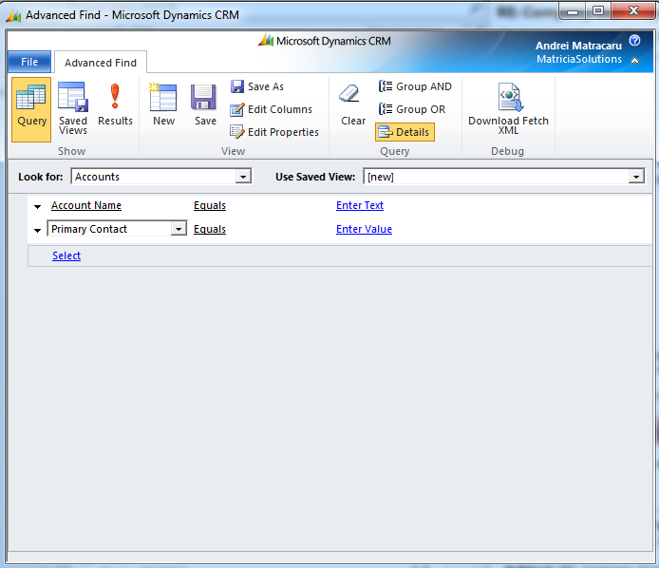

*Advanced Find*

# Account Management

## Accounts

Accounts represent companies that your organization may do business with. The CRM Account entity contains information about prospects, clients, architects, developers, constructors, real estate agents and others. The segmentation of the account type is done primarily by the Relationship Type field.

To access the list of Account records defined in the system, in the **Navigation** menu, click **Workplace**, and then under **Customers** click **Accounts**. You can also access the account lists from the Sales area of the Navigation menu.

From the Accounts list, as with any other entity type, you can create a new record using the **New** button on the ribbon menu.

Please note that when creating a new account the Account Number and Year Became Client fields will be automatically populated by the system when the first Order record related to the Account is created (upon closing an Opportunity as Won). You must **not** populate these two fields when creating a new Account, nor edit their information afterwards.

The Account Number and Year Became Client are only relevant for accounts with the Client relationship type.

### Hierarchical Accounts

To record information regarding hierarchical relations between accounts (such as headquarters and branch offices) you can use the **Parent** **Account** lookup on the account form when defining the child account record to select the parent (headquarter). Note that if the parent record is not defined in the system it must be created.

**NOTE**

For child accounts the system will **NOT** generate a new account number but will use the parent’s account number instead.

Account records with the Client relationship type will only receive a unique account number if the Parent Account field does not contain any data.

### Addresses

An account record can have more than one address. The primary address of an account is defined directly on the account form in the Address section, like illustrated in the image below.

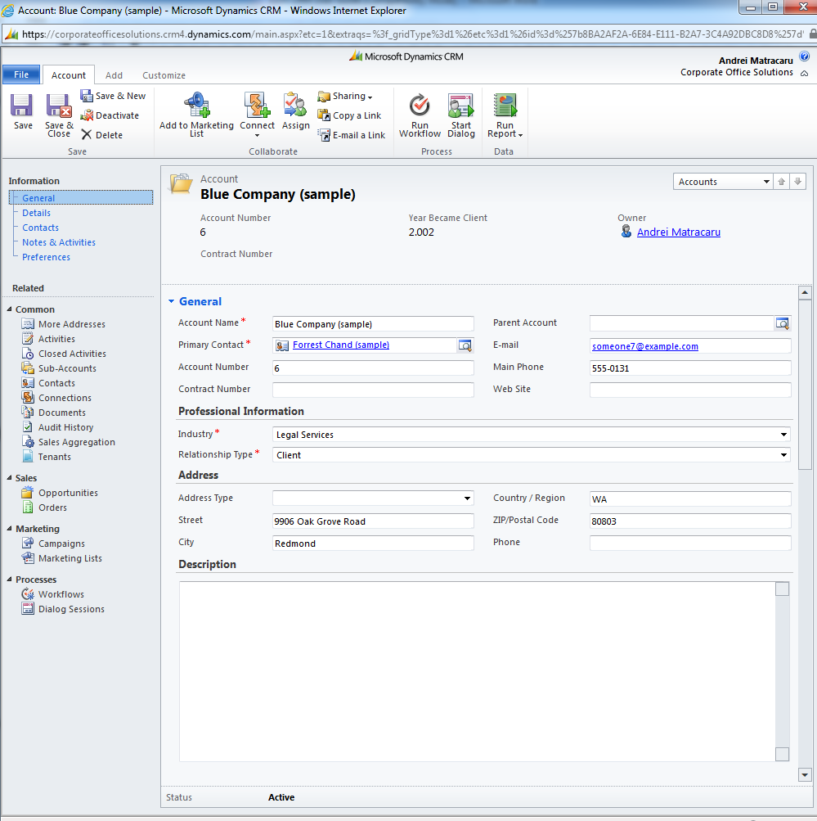

*Account Form*

To define more addreses for an account you can use the **More** **Addreses** link on the left navigation bar of the form to view the list of addreses defined for the current account and click the **Add** **New** **Address** button from the ribbon.

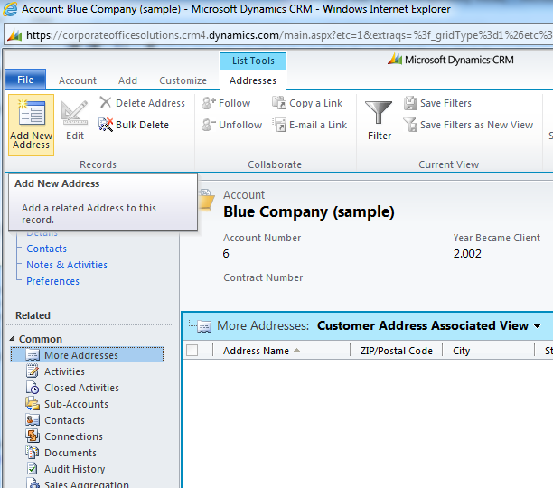

## Contacts

Contacts are people who represent customers or potential customers, or someone related to an account.

To access the list of Contact records defined in the system, in the **Navigation** menu, click **Workplace**, and then under **Customers** click **Contacts**. You can also access the contact lists from the Sales and Marketing areas of the Navigation menu.

**NOTE**

A contact can only have one parent account, in essence the contact can only be related to a single account record. An account record can have more than one related contacts, but a single contact record can be selected as Primary Contact.

### Outlook Integration

By default, all contact records created by you in Microsoft Dynamics CRM Online will automatically be synchronized to your Outlook contact list.

Alternatively, you can save Outlook contacts as new Microsoft Dynamics CRM Online contacts. You can link the newly saved record to another Microsoft Dynamics CRM Online record, such as an account:

1. In the Outlook contacts folder, select up to 20 contacts.
2. If you have Outlook 2007 installed, on the CRM Toolbar, click Track in CRM.

- OR -

If you have Outlook 2010 installed, in the CRM group, click Track.

In the Outlook Contacts folder, if the contacts are displayed in a list, the Tracked in CRM icon is displayed and indicates that the contact is tracked.



The contacts appear in the Contacts area in Microsoft Dynamics CRM Online.

1. To link the contacts to a parent record, in Outlook, in the CRM group, click Set Parent. Click the type of record. In the Look Up Record dialog box, click the record that you want, and then click OK.

## Buildings and Tenants

The **Building** entity will store information regarding office, hospitality, healthcare and other types of buildings involved in your organization’s business.

To access the Building list in the CRM system, in the **Navigation** menu, click **Sales**, and then click **Buildings**.

When you create a new Building record, you must enter information regarding the category, class, development stage, square meters and also address.

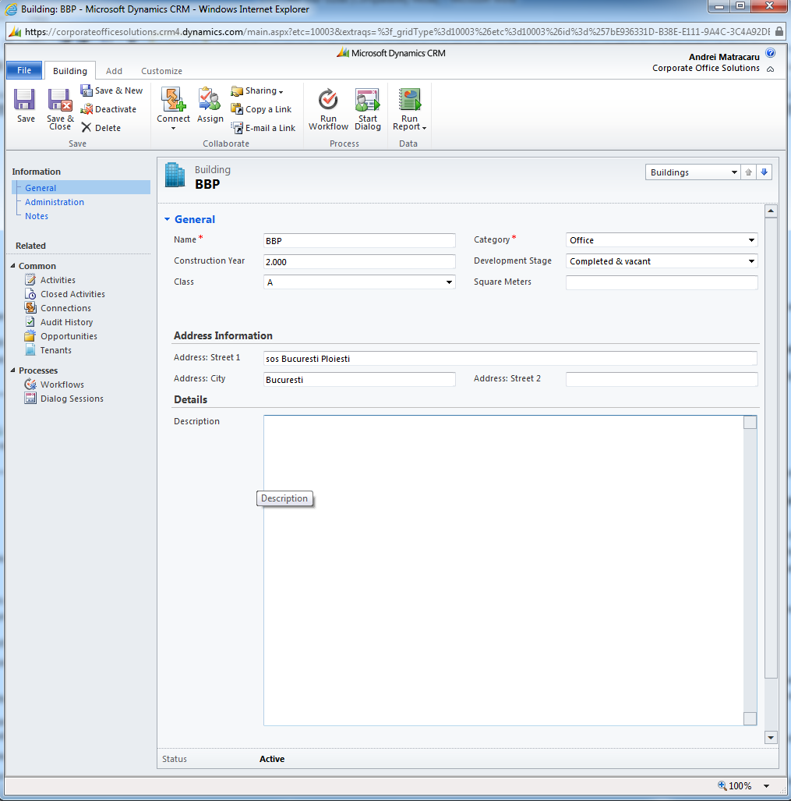

*Building Form*

The **Tenant** entity will be used to link the Accounts and Building records along with additional information relevant to your business, such as lease contract expiration date.

You can access Tenant information from the **Sales** area of the Navigation menu (the whole Tenant list), or from Account or Building records (only Tenants related to that Account or Building).

When you create a new Tenant record you must specify Account and Building information, and can also specify Current Supplier (Competitor record), Square Meters, No. of Workstations, Contract Expiration Date and other Observations. Note that when creating a new Tenant record the Name field will automatically populate after you save the record.

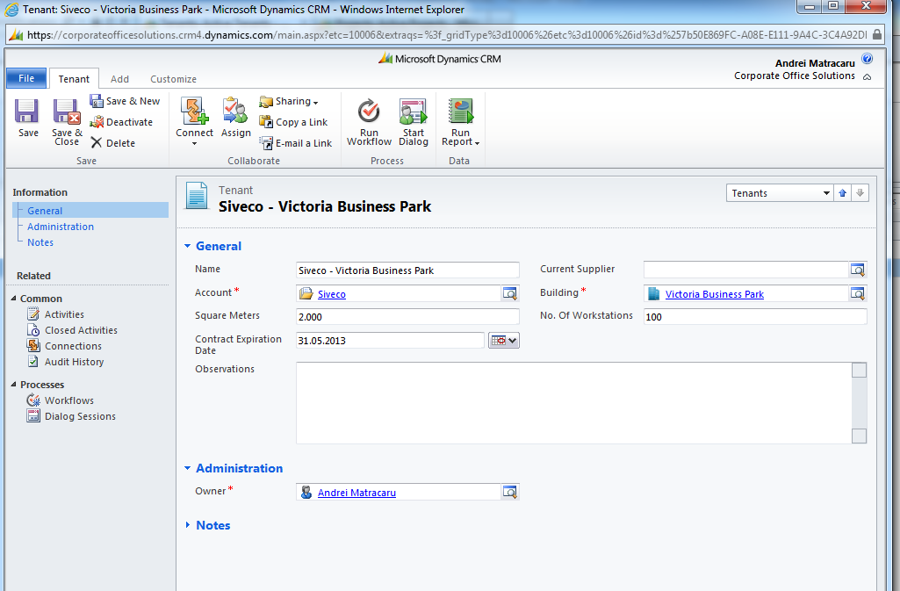

*Tenant form*

**NOTE**

The system will automatically generate a task to notify the related Account owner when the contract information recorded in the Tenant records will expire in one year.

## Competitors

Competitors represent people or organizations that your business unit competes with for sales [opportunities](javascript:toggleInline('27657')).

To access the list of Competitor records defined in the system, from the **Navigation** menu, click **Sales**, and then click **Competitors**.

Tracking competitors is a key aspect of a sales process. The more information that your team has about a competitor's strengths, weaknesses, opportunities, and the threats a competitor might have to your organization's ability to make a sale, the more likely you are to win against that company.

Competitor records can be linked to opportunities to record the potential threats to an ongoing deal.

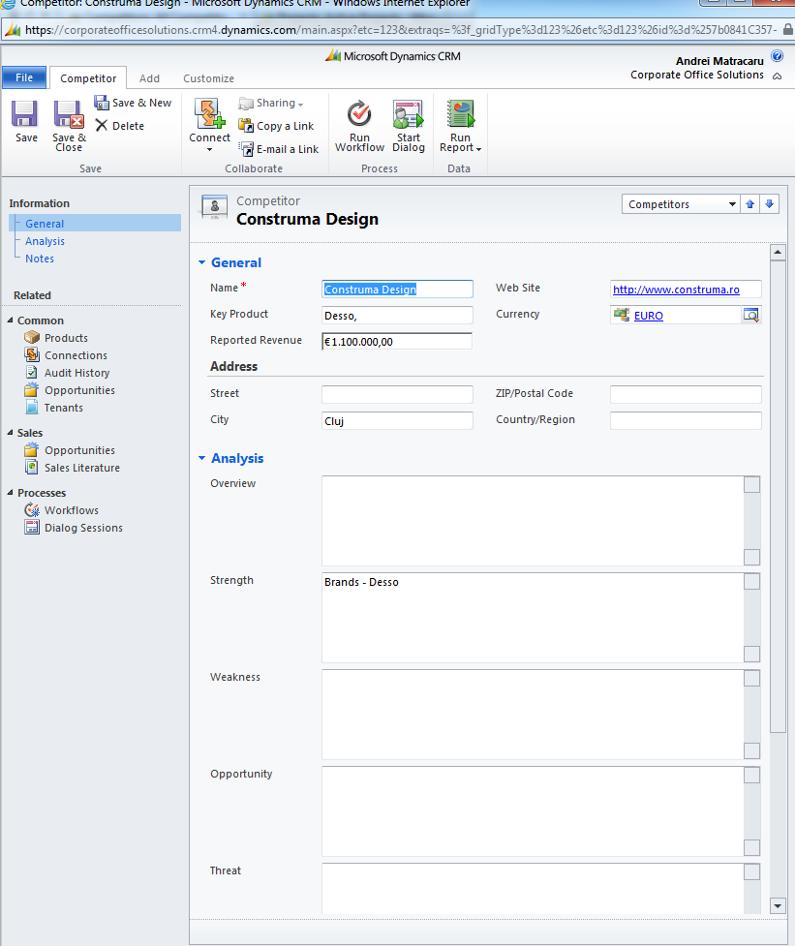

*Competitor form*

## Connections

You can use the CRM system to create relationships between records. For example, you may want to link an architect or real estate agent account to a client or to a building, a contact record to an opportunity as an influencer and so on.

Connections are a free form of relationships between records that can be used to connect any type of record to any other type of record.

In Microsoft Dynamics CRM Online, you can create and view the relationship between two records by using the **Connect** button from the ribbon. When you open a record, you can view all of the connections between it and other records by clicking **Connections** on the left navigation pane of the record form.

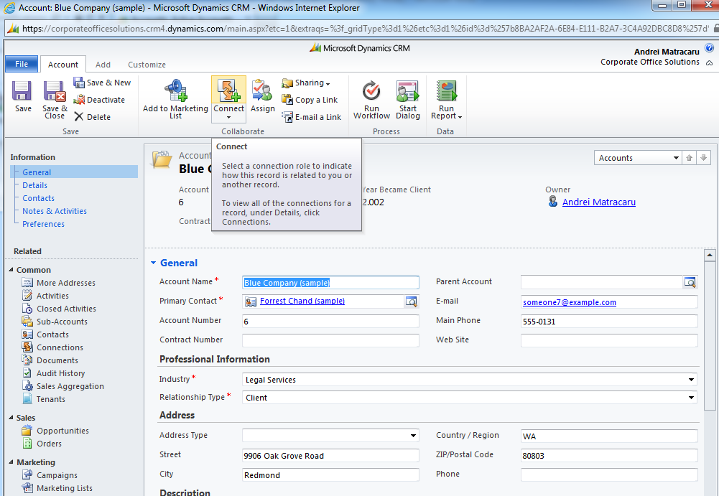

*Connect button on Account form ribbon*

Microsoft Dynamics CRM Online offers several different roles you can use to identify your connection types. The options are not limited. Your system administrator can add new role types.

### Create a connection

To create a new connection between two records follow these steps:

1. Select the record to which you want to add a connection to, and in the **Collaborate** group on the ribbon menu, click **Connect**.

2. Next to the **Name** field, click the **Lookup** button to search for and select the record you want to connect to.



3. Next to the **As this role** field, click the **Lookup** button to select the role for the record you want to connect to.



4. Click **Save** or **Save and Close**.

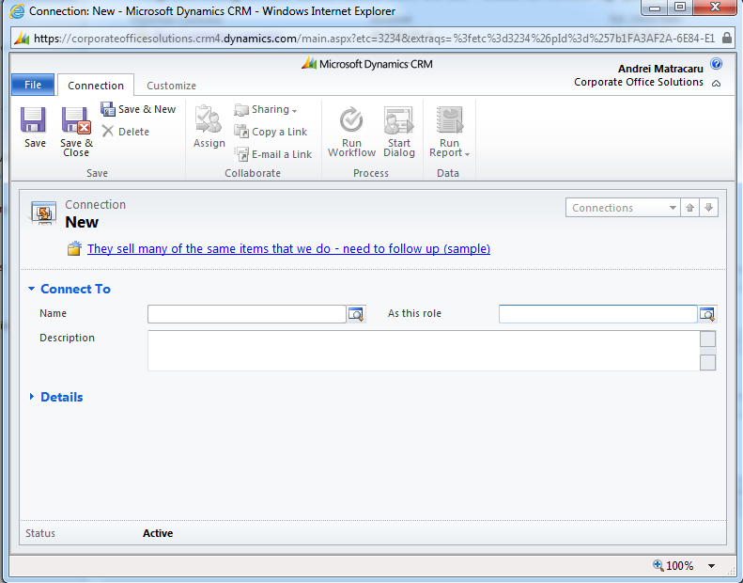

*New Connection Form*

# Sales Process Management

## Opportunities

An [opportunity](javascript:toggleInline('26866')) is a potential revenue-generating event or sale to an account that needs to be tracked through a sales process to completion. With an opportunity record you can forecast sales revenue, set a potential close date, and factor in a probability for the sale to occur.

When you create an opportunity, you must specify an existing account record. If the account record you wish to relate the opportunity to does not exist, it must be created. Also, an opportunity requires that you link the record to a particular [project](javascript:toggleInline('26868')) type. This is needed for the automated pre filtering of the proposed products that the customer is interested in purchasing.

Using opportunities in your business process enables you to run pipeline reports to view estimated revenue flows based on pending new sales.

To view the list of opportunities defined in the system, from the Navigation menu, click **Sales**, and then click **Opportunities**.

### Creating Opportunities

You can create a new opportunity either from the Opportunities list (Navigation menu, click **Sales**, and then click **Opportunities**) or from an Account record (Opportunities link on the account form’s left navigation pane). When you create the Opportunity record directly from the Account, the system will automatically pre-populate the Potential Customer field with the current account information.

You can use Microsoft Dynamics CRM Online to track information about each opportunity, such as:

* Contact information.
* Building information (for example, where the potential customer is moving to)
* Salesperson who is actively working on the opportunity.
* Source of the opportunity
* Assessment on the probability of [closing](javascript:toggleInline('26871')) the sale and turning the opportunity into a customer.
* Projected closing date of the sale and estimated value.
* Category and Sales pipeline phase
* Threats and competitors
* Products or services that the customer is interested in buying

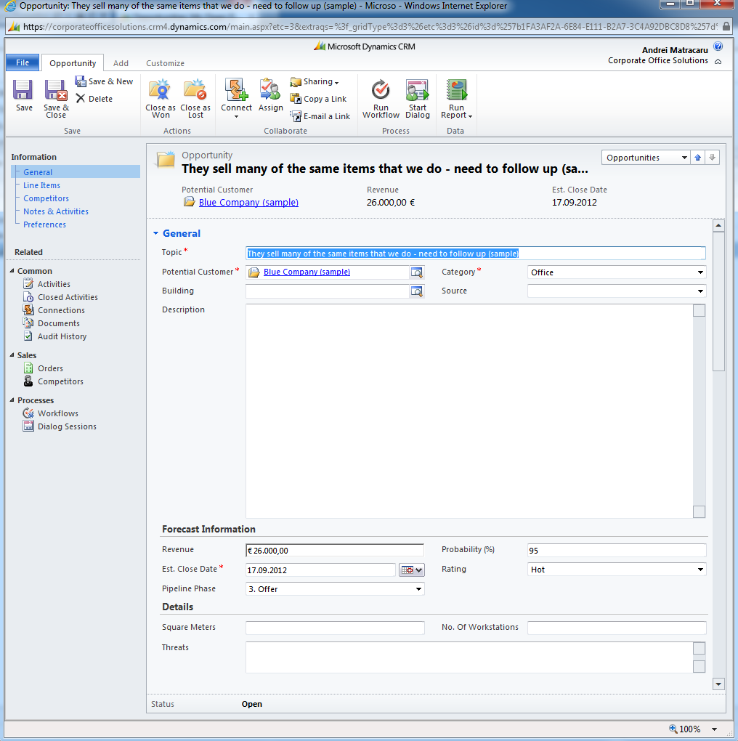

*Opportunity Form*

#### Opportunity Products

After creating an opportunity record, you can associate the products that the customer is interested in. To do this, select the Opportunity Products list on the Opportunity Form (directly below the Project Type lookup) and click **Add** **New** **Opportunity** **Product** button on the ribbon.

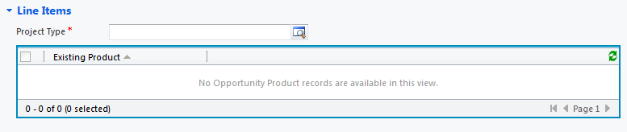

*Opportunity Product list on the Opportunity Form*

Note that in order to be able to add an opporunity product you must first select a Project Type record on the opporunity. Also, you can only select products or services compatible to the selected Project Type.

#### Opportunity Competitors

To record the competition involved in the opportunity’s sales process, you can add Competitor records to the opportunity. To do this, select the Competitor list on the Opportunity Form and click **Add** **Existing** **Competitor** button on the Ribbon. If the Competitor record you are looking for is not defined in the system, you can create it by clicking the **New** button in the lookup dialog that opens.

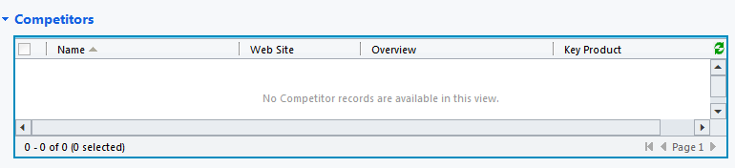

*Competitor list on the Opportunity Form*

### Closing Opportunities

Whether you win a sale or lose it, you must [close](javascript:toggleInline('25769')) the opportunity record. You will have the option to reopen the opportunity later if it becomes a viable sale. To close an opportunity:

1. Open the opportunity you want to close.
2. In the **Actions** group, click **Close as Won** or **Close as Lost**.
3. In the **Close Opportunity** dialog box, click a **Status** option.

If you select **Won**, enter the appropriate information in the following fields:

* + **Actual Revenue**

This value should represent the actual agreed upon price.

* + **Close Date**

Date that the deal was closed on. By default, the system automatically populates the current date.

* + **Description**

Enter the reason for the win.

If you select **Lost**, enter the appropriate information in the following fields:

* + **Status Reason**

Select an option: **Canceled** or **Out-Sold**.

* + **Close Date**

Date that the deal was closed on. By default, the system automatically populates the current date.

* + **Competitor**

If you know the competitor you lost the deal to, click the **Lookup** button to search for a competitor.



* + **Description**

Enter the reason for the loss.

1. Click **OK**.
2. Click **Save** or **Save and Close**.

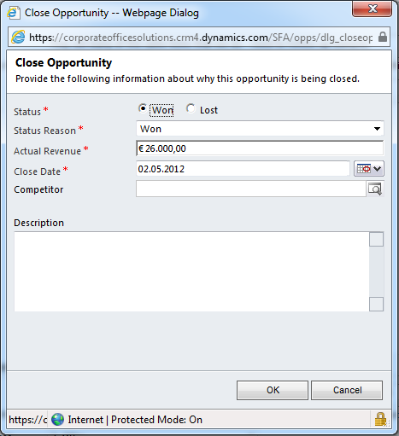

*Close Opportunity dialog*

**NOTE**

After you close an opportunity as either Won or Lost, the opportunity record becomes read only and you can no longer edit its information in this state. To edit the information, you must reopen the opportunity (see below).

If an opportunity is closed as Won, the system will automatically start an asynchronous operation that will create a new Order record based on the information from the opportunity.

### Reopen an Opportunity

An [opportunity](javascript:toggleInline('25841')) you previously closed might become viable again or you might want to edit its information. If this occurs, you can reopen the opportunity. To reopen a closed opportunity you must do the following:

1. In the Navigation menu, click **Sales**, and then click **Opportunities**.
2. In the **View** list, click **Closed Opportunities**.
3. In the list of opportunities, open the opportunity you want to reopen.
4. In the **Actions** group, click **Reopen Opportunity**.
5. In the **Reopen This Opportunity** dialog box, click **OK**.
6. Click **Save** or **Save and Close**.

## Orders

While Opportunity records contain information about potential sale deals, Order records represent the actual sale.

Orders are automatically created in the system each time an opportunity is closed as Won. Information regarding Customer, Project Type, Owner and Sales Volume are taken directly from the related Opportunity. Also, by default the Order Date is set to the Closing Date of the Opportunity, but can be modified manually.

Information regarding Contract Number, COS Group, Address and Cost will be completed by the Sales Support department.

**NOTE**

Orders must **not** be created manually in the system , they will be created automatically when an Opportunity is closed as Won

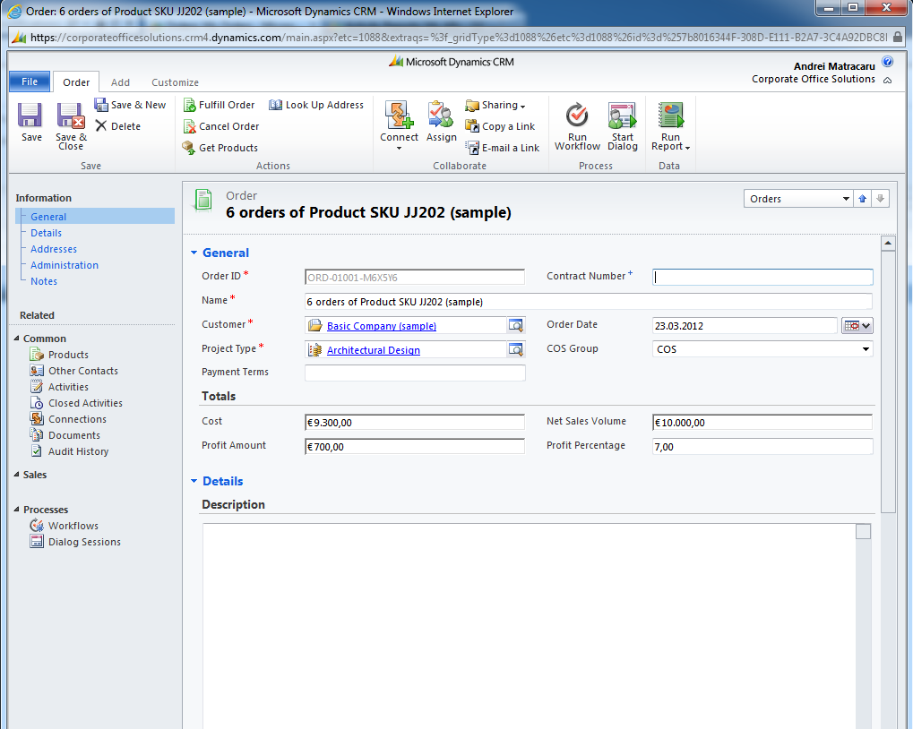

*Order Form*

### Order Information

After an order is created, the following tasks must be completed by the Sales Support department for each new Order record:

1. Set Contract Number information
2. Select COS Group value
3. Set Cost information – Profit Amount and Profit Percentage will be calculated automatically based on Net Sales Volume and Cost
4. Populate the Order Products from the Opportunity – this is easily achieved by clicking the **Get** **Products** button on the ribbon of the Order Form; the user will be presented with a dialog to confirm the opportunity from which product information will be taken (by default the opportunity that generated the Order)

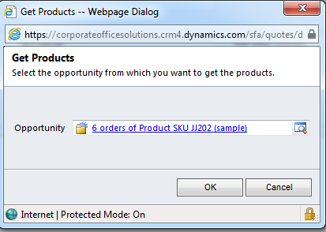

*Get Products confirmation dialog*

1. Populate address information for billing and shipping – although Order address information can be completed manually using the address fields on the order form, the CRM system provides a functionality to search for one of the Customer’s addreses and select it to be completed automatically;

This is achived by clicking the **Look** **Up** **Address** button on the Order form ribbon. The user is presented with a dialog to select the address (from the Cutomer’s defined addresses) and which section to use the selected address for (billing, shipping or both). After an address is selected, the corresponding fields are populated on the Order form.

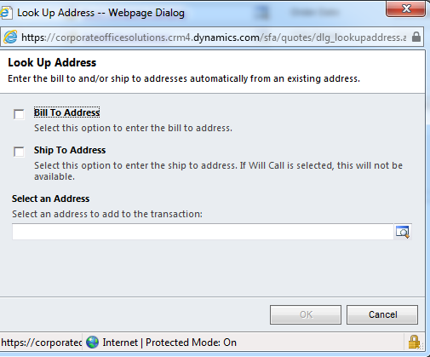

*Look Up Address dialog*

1. Upload client order document in SharePoint from the CRM Order record (**Documents** link in the Order form left navigation pane -> **Add** button)
2. Close Order as Fulfilled

Order records without Cost information are visible using the **Orders** **without** **Cost** **Information** view on the Order entity list.

**NOTE**

When completing the Contract Number field on the Order the system will automatically copy the contract number to the related account record

### Close Orders

Once all the necessary information was filled-in by the Sales Support department, an Order must be closed as Fulfilled.

To close an Order, the Sales Support user must click the **Fulfill** **Order** button on the Order form ribbon. Once an Order is closed as Fulfilled, it becomes read-only.

**NOTE**

An order should only be closed as Fulfilled after all necessary information is completed.

### Reopen Order

If a closed Order needs to be modified, it can be reopened. To reopen a closed Order, open the order record, and click the **Start** **Dialog** button on the form ribbon. Next, select the Re-open Order item in the dialog, click Ok and follow the instructions on screen. At the end of the process, the Order record will be re-opened.

Note that to view the changes, you must close and open the order record, or press **F5** button on your keyboard while in the Order form.

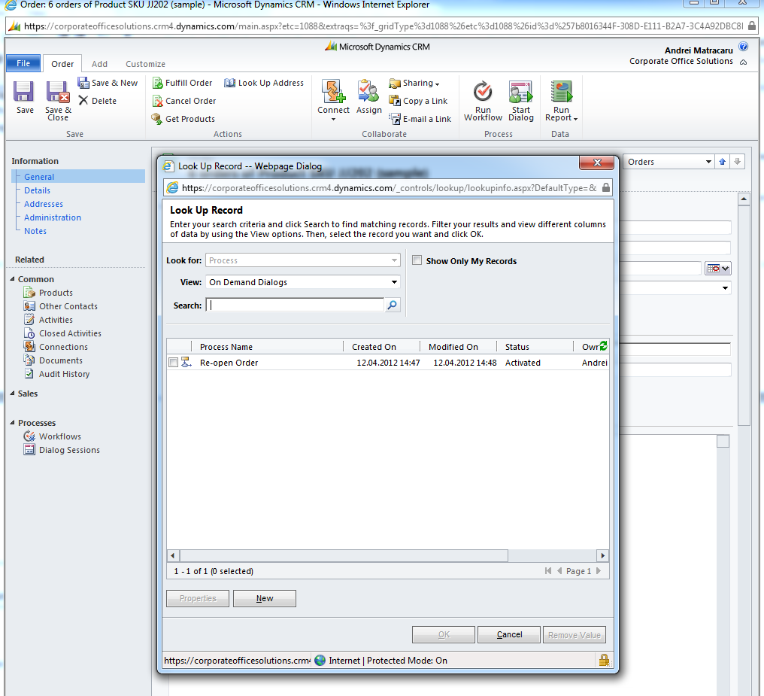

*Re-open Order dialog selectio list*

**NOTE**

After an Order is reopened and modified, it must be closed again as Fulfilled.

# Document Management

Documents attached to CRM records will be stored in Microsoft SharePoint. Microsoft SharePoint is a document management system seamlessly integrated with Dynamics CRM Online which you will use to attach documents to CRM records and collaborate on them with your team.

All interactions with the documents stored in SharePoint related to CRM records will be managed directly from the CRM interface.

To access the documents attached to a CRM record, open the record form and click **Documents** on the left navigation pane.

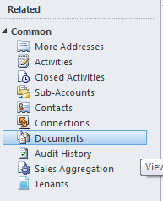

*Documents link on the Account form navigation pane*

**NOTE**

Document management capabilities will only be enabled on Account, Opportunity and Order entities.

Before you can manage documents for a record from Microsoft Dynamics CRM Online, you must create a location record in Microsoft Dynamics CRM Online that points to libraries and folders on SharePoint where the documents will be stored. The CRM system will do this task automatically the first time you access the documents section on a record.

1. Open the Microsoft Dynamics CRM Online record that has the documents you want to manage.
2. On the left navigation pane, click Documents.
3. If a location is not associated, Microsoft Dynamics CRM Online will display the Create SharePoint Location dialog box. Microsoft Dynamics CRM Online tries to automatically create a folder in SharePoint. If the folder is created successfully, Microsoft Dynamics CRM Online opens Create SharePoint Location with the URL of the new folder. Microsoft Dynamics CRM Online creates a document location record that contains the URL of this new folder and associates the document location record with the Microsoft Dynamics CRM Online record.
4. Click OK

A new document location record is created in Microsoft Dynamics CRM Online that contains the links to the folders in SharePoint. The location that you just associated is added to the Document Locations list.

##### Use documents stored in SharePoint from Microsoft Dynamics CRM Online

1. On the record form, on the left navigation pane, click **Documents**
2. From the **Document Locations** list, click the location that has the documents that you want to manage or work on.
3. Perform any of the following tasks.

|  |  |
| --- | --- |
|  |  |
| Basic Tasks | |
| Tasks | Do This |
| Create a document using a template | On the Actions toolbar, click **New**, and then click **Document**.  Note  When you create a document using a template and try to save it, Microsoft Dynamics CRM Online suggests a location (SharePoint folder) in **Save As** when saving the document. If you save the document to a location other than the one that is suggested, the document is not visible in the Documents area. |
| Create a folder | On the Actions toolbar, click **New**, and then click **Folder**. |
| Add a document from your computer and store it in the SharePoint folder | On the Actions toolbar, click **Add**. |
| Edit a document | On the Actions toolbar, click **Edit**. |
| Delete a document from the SharePoint site | On the Actions toolbar, click the **Delete** button . |

|  |  |
| --- | --- |
|  |  |
| Additional Tasks | |
| Tasks | Do This |
| Check out a selected document | On the Actions toolbar, click **Actions**, and then click **Check Out**. |
| Check in a document that is checked out | On the Actions toolbar, click **Actions**, and then click **Check In**. |
| Discard any changes to a checked-out document and keep the last version. | On the Actions toolbar, click **Actions**, and then click **Discard**. |
| Receive a notification when a document changes | On the Actions toolbar, click **Actions**, and then click **Alert Me**. |
| Download a copy of the selected document to your local computer | On the Actions toolbar, click **Actions**, and then click **Download a Copy**. |
| Copy the shortcut of the selected location where the document is stored | On the Actions toolbar, click **Actions**, and then click **Copy Shortcut**. |
| Send the shortcut of the document location to another user | On the Actions toolbar, click **Actions**, and then click **Send Shortcut**. |
| View the properties of a selected document | On the Actions toolbar, click **Actions**, and then click **View Properties**. |
| Edit the properties of a selected document | On the Actions toolbar, click **Actions**, and then click **Edit Properties**. |
| View the version history of a document | On the Actions toolbar, click **Actions**, and then click **Version History**. |
| Open the document location in SharePoint in a different browser window | On the Actions toolbar, click **Open** SharePoint. |

Important: the document actions are available to you based on the permissions you have on the SharePoint document library.

For more information about the SharePoint Document Management capabilities, see the Microsoft SharePoint Server 2010 documentation.

# Reporting and Analytics

## Reports

Reports allow you to analyze the data in Microsoft Dynamics CRM Online from different perspectives. The reports created in the CRM system are grouped in 4 categories:

* + Administrative Reports
  + Marketing Reports
  + Sales Management Reports
  + Sales Situation Reports

You can view the reports in each category by selecting the view with the same name in the Reports list.

To run a report, follow the next steps:

* 1. In the **Workplace**, under **My Work**, click **Reports**.
  2. To narrow the list, enter the first few letters of the report name, or use the asterisk (*) wildcard in the search box, and then click the **Find** button . You can also select a view from the **Reports** drop-down box.



* 1. In the reports list, double-click the report that you want to run.
  2. If the report has a [default filter](javascript:toggleInline('25372')), the default filter will be displayed. Follow steps described in the next section to change the filter.

To run a report without seeing the default filter, select the report. On the **Reports** tab, in the **Actions** group, click **Run Report**.

**NOTE**

All the reports defined in the CRM system run on real time data. That means that every time you run a report, the data contained in it is the exact snapshot of the current data present in the system.

### Report Filtering

Report filtering means criteria used to limit data shown in reports. Some reports have a default filter set. Typically, the default filter restricts data to records that have been created within a certain time period.

If a report contains filtering criteria, if needed, you can modify the filter criteria before you click Run Report. The pre-filtering criteria can also be modified after a report is run, by clickingthe **Edit** **Filter** button.

The list of existing report filtering criteria is grouped by record types that you can use in the filter, such as **Accounts** or **Contacts**.

To add a criteria row:

1. Click **Select**, and specify the field to filter on.
2. Click the [query relational operator](javascript:toggleInline('23867')) (Part of an expression (for example "is equal to" or "contains") that defines how a specified attribute should be compared with a value.), and select an operator.
3. Click **Enter Value**, and enter a value to filter on. For some values, you can click the **Select or change the values for this field** button to open the **Select Values** dialog box and select the value you want.



1. To group criteria, you must select two or more rows for the same record type. For example, **Sales Stage** and **Est. Revenue** are both field values in the **Opportunity** record type and two rows that specify filter criteria for these fields can be grouped. However, rows with field values from different record types, such as **Account** and **Opportunity** record types, cannot be grouped.
2. For each row you want to group, in detailed mode, click the **Options menu** button for that row, and then click **Select Row**.



1. On the Filter toolbar, select **Group AND** or **Group OR**.
2. To remove a row from a group, click the **Options menu** button for that row, and then click **Delete**.



1. To select a group, click the **Options menu** button for that group, and then click **Select Group**.



1. To add a criteria clause to a group, click the **Options menu** button for that group, click **Add Clause**, and then select the field, query relational operator, and value.



1. To unselect a group that has been previously selected, click the **Options menu** button for that group, and then click **Deselect Group**.



1. To ungroup a group, click the **Options menu** button for that group, and then click **Ungroup**.



1. To change a **Group AND** group to a **Group OR** group, or a **Group OR** group to a **Group AND** group, click the **Options menu** button for that group, and then click **Change to OR** or **Change to AND**.

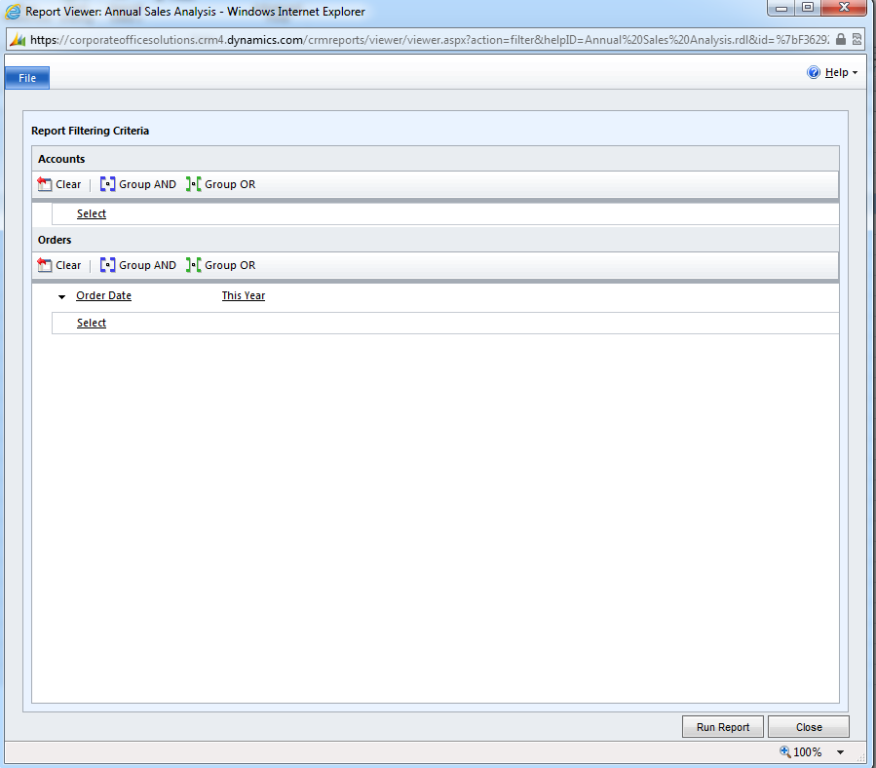

*Report filter editor*

### Exporting Reports

After a report is run, you can export the data to a file for later referencing if, for example, you don’t have an internet connection and thus access to the system. The exported report is temporary. If you need to save the exported report to a local file, use the viewing program to save the file to disk. The saved exported report is no longer connected to Microsoft Dynamics CRM Online. Therefore, it does not change if Microsoft Dynamics CRM Online data changes.

To export a report after it is run, click the **Export** button and select a format to which you want to export the report.



The list of export formats available to you may vary from those listed here.

* + - **XML file with report data**

View the report as an XML file.

* + - **CSV (comma delimited)**

View the report as a text file, with fields separated by commas. This format includes all the row, column, and field labels.

* + - **Acrobat (PDF) file**

View the report using a client-side PDF viewer. You must have Adobe Acrobat Reader to use this format.

Choose this format for long reports, paginated reports, or reports that are delivered as a file.

* + - **MHTML (web archive)**

View the report in Microsoft Internet Explorer, as a MIME-encoded HTML format that keeps images and linked content together with a report. For chart reports, if the chart is not displayed correctly the first time that you export the report, export the report again.

Choose this format to view a report offline or for e-mailing the report.

* + - **Excel**

View the report in Microsoft Office Excel. This format includes all the row, column, and field labels, in addition to report formatting.

Large reports and reports with charts might not display with the expected formatting when exported in this file format.

* + - **TIFF file**

View the report in the default TIFF viewer. For some Windows clients, this is the Windows Pictures and Fax Viewer.

Choose this format to a view a report in a page-oriented layout. The TIFF format is the recommended format for printing reports.

* + - **Word**

View the report in Microsoft Office Word. This format includes all the row, column, and field labels, in addition to report formatting.

## Charts

Charts present your organization's data graphically. Data presented in charts can quickly give you insight into large quantities of data that is spread across different areas of your business. This helps you make relevant and timely decisions.

Microsoft Dynamics CRM Online associates charts with record types. It generates charts using the data in the list of records for any record type.

Because charts are created in the context of a list of records, changing the view of a list also changes the chart. Filtering a list of records changes the chart to show the filtered data. Similarly, drilling down in a chart updates the list of records to show the new data.

You can view the charts from the main list of records or from the list of associated records for an individual record. For example, you can view a chart for a list of account records. Otherwise, you can view a chart for the Opportunity line item of any account record.

To view a chart for a list of associated records, open a record, click the line item of the associated record type, on the <*record type*> tab, click **Charts**, and then click **Right**. For example, open an account record, and under **Sales**, click **Opportunities**. On the **Opportunities** tab, click **Charts**. If there is an existing chart created for this associated record type, the chart will be displayed to the right of the list of the associated records.

NOTE

A chart will not display if you select the **Related Regarding Records** filter from the **Include** drop-down box for a list of associated records.

When you are viewing charts in context of the list of records, you can apply filters on the list of records, or you can drill down in a chart:

1. On the main page of the list of records, click the chart bar on the right or top of the list of records.
2. In the charts area, click the arrow next to the chart name, and then click the name of the chart that you want to view from the list of charts.

The chart preview changes depending on the view that you selected.

1. [Analyze the data in the chart.](javascript:toggleBlock('50201'))

You can either apply a filter on the list to view an updated chart of the narrowed down items or you can drill down in a chart to obtain specific details about an item.

When you drill down in a chart, the data in the list of records is filtered automatically based on the drill-down options you provide:

* + [Apply filter](javascript:toggleBlock('50199'))
    1. On the main page of any list of records, click the name of the view to use to generate the chart from the <*record type*> list.
    2. To see a chart for the record type, click the chart bar on the right or top of the list of records.
    3. Click the arrow next to the chart name, and then click the name of the chart that you want to see.
    4. On the **View** tab, in the **List** group, click **Filter**.
    5. On the column on which you want to apply a filter, click the **Filter** button , and then click one of the default filters for the column or click **Custom Filter**.



If you clicked **Custom Filter**, specify criteria for the filter.

* + - 1. In the **Custom Filters** dialog box, click one of the default query operators from the first list.
      2. In the next box, enter a value for the query operator.
      3. Click one of the default query operators from the second list.
      4. In the box next to the second list, enter a value for the query operator for the second criteria.
      5. Depending on whether you want both these criteria to be met, click **And** or **OR**.
      6. Click **OK**.
    1. In the chart area, click **Refresh Chart**.

The chart is refreshed, and the updated data obtained from the view and list is displayed in the chart.

Note

When you change the layout of a chart, all the filters applied on the view are reset. To retain the filters, save the view as a new view before you change the layout.

* + [Drill down in a chart](javascript:toggleBlock('50200'))
    1. Open the list of records that you want to view a chart. Then, click the chart bar on the right or top of the list of records.
    2. In the chart area, click the arrow next to the chart name, and then click a name of the chart that you want to see or for drilling down.
    3. Click the category area of the chart in which you want to drill down further to see lower level data.
    4. In the shortcut menu, click **Select Field**, and then click the field by which you want to group the category.

For example, you are viewing a chart that shows opportunities by potential customers. You want to drill down to see the opportunities for one potential customer, grouped by probability. Click the potential customer on the chart, click **Select Field**, and then click **Probability**. The chart now shows the opportunities for this customer with the probability of each opportunity.

* + 1. Click the corresponding icon for a chart type that you want use for viewing the data.
    2. Click **OK**.

You can drill down even further on the resulting chart from the drill down on a chart.

To go to the chart from which you drilled down, click **Back**.

NOTE

* To place the chart on the right or on top of a list of records, on the **Charts** tab, in the **Layout** group, click **Chart Pane**, and then click **Right** or **Top**. To close the chart pane, on the **Charts** tab, in the **Layout** group, click **Chart Pane**, and then click **Off**.
* In any list of records, to collapse a chart pane that is placed on the right of a list of records, click the **Click here for Collapsed View** button. To open the chart pane, click the **Click here for Normal View** button .



* You cannot drill down in chats that you are viewing from a list of associated records.

## Dashboards

Dashboards provide a way to combine data from different areas in a single place. The data is formatted to be easier to understand to provide quick insights. You can use the dashboard components for more in-depth information about the records.

The following dashboards are defined in the CRM system:

* + Corporate Office Solutions Overview – shows general information about the current sales pipeline and company goals for the current period
  + Company Sales Performance – detailed information about sales revenue, profit, pipeline and yearly company goals
  + My Sales Activity – information about the current user’s sales pipeline, top opportunities and customers, yearly goals and open activities list
  + Sales Leaderboard – information about sales volume and profit by user, and also won vs lost deals
  + Sales Support – information about the user’s activities and Orders without Cost information
  + Marketing – information about the current marketing campaigns, revenue generated from campaigns, campaign budget vs cost

### [Drill down in a chart](javascript:toggleBlock('52405'))

1. In the Navigation Pane, click **Workplace**. Then, under **My Work**, click **Dashboards**.
2. In the **Dashboard** list, click the name of the dashboard that you want to open.
3. Click the category area of the chart in which you want to drill down further to see lower level data.
4. In the shortcut menu, click **Select Field**, and then click the field by which you want to group the category.

For example, you are viewing a chart that shows opportunities by potential customers. You want to drill down to see the opportunities for one potential customer, grouped by probability. Click the potential customer on the chart, click **Select Field**, and then click **Probability**. The chart now shows the opportunities for this customer with the probability of each opportunity.

1. Click the corresponding icon for a chart type that you want use for viewing the data.
2. Click **OK**.

You can drill down even further on the resulting chart from the drill down on a chart.

### [Enlarge a chart](javascript:toggleBlock('53057'))

1. In the Navigation Pane, click **Workplace**. Then, under **My Work**, click **Dashboards**.
2. In the **Dashboard** list, click the name of the dashboard that you want to open.
3. Move the pointer over the chart and pause, and then click the **Enlarge the chart** button .



### [View the records that are used to generate the chart.](javascript:toggleBlock('52413'))

1. In the Navigation Pane, click **Workplace**. Then, under **My Work**, click **Dashboards**.
2. In the **Dashboard** list, click the name of the dashboard that you want to open.
3. Move the pointer over the chart and pause, and click the **View the records that are used to generate the chart** button .



### [Apply filters on the list](javascript:toggleBlock('52416'))

1. In the Navigation Pane, click **Workplace**. Then, under **My Work**, click **Dashboards**.
2. In the **Dashboard** list, click the name of the dashboard that you want to open.
3. Click the component area that contains the list of records.
4. In the **Current View** group, click **Filter**.

A **Filter** button is now available for all the columns in the list.



1. On the column on which you want to apply a filter, click the **Filter** button . Then do one of the following:



* + Click one of the default filters for the column.

- OR -

* + Click **Custom Filter**, choose how to filter the records, and then click **OK**.

### [Refresh all components in the dashboard](javascript:toggleBlock('53055'))

1. In the Navigation Pane, click **Workplace**. Then, under **My Work**, click **Dashboards**.
2. In the **Dashboard** list, click the name of the dashboard that you want to refresh.
3. In the **Action** group, click **Refresh All**.